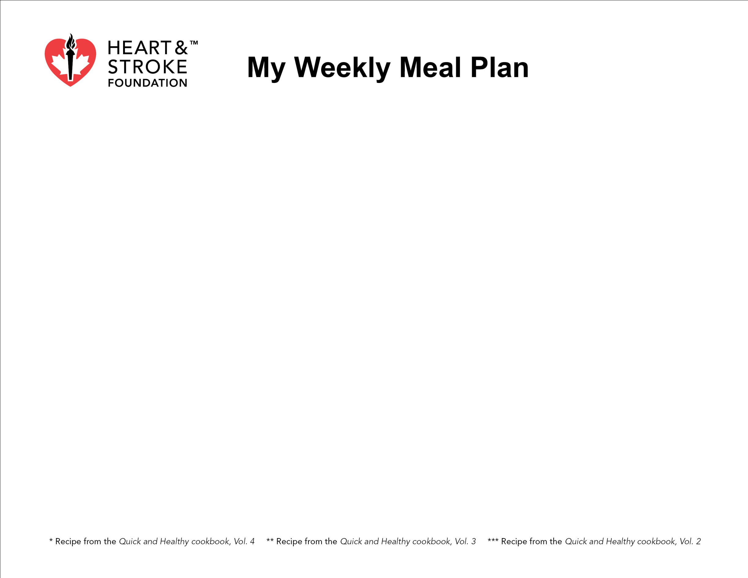
Day | Monday | Tuesday | Wednesday | Thursday | Friday | Saturday | Sunday
Breakfast

Children who eat breakfast often make healthier food choices throughout the day.
Lunch

Eating 5 or more servings of fruit or vegetables per day can reduce your risk of heart disease and stroke
by about 20%.
Dinner

Save time on a busy night by batch cooking soups, stews and casseroles.
Snack
Aim for 2 food groups with each snack.

